**Ideation Phase**

**Brainstorm & Idea Prioritization Template**

|  |  |
| --- | --- |
| Date | 16 June 2025 |
| Team ID | LTVIP2025TMID55634 |
| Project Name | Booknest: Where Stories Nestle |
| Maximum Marks | 4 Marks |

**Brainstorm & Idea Prioritization Template:**

Brainstorming fosters an open and inclusive environment where every team member is encouraged to actively engage in creative thinking to drive problem-solving. Emphasizing the generation of a large volume of ideas over immediate value, this process welcomes unconventional and innovative thoughts. Team members are inspired to build on one another’s suggestions, promoting collaboration and the development of a diverse pool of creative solutions.

**Step-1: Team Gathering, Collaboration and Select the Problem Statement**

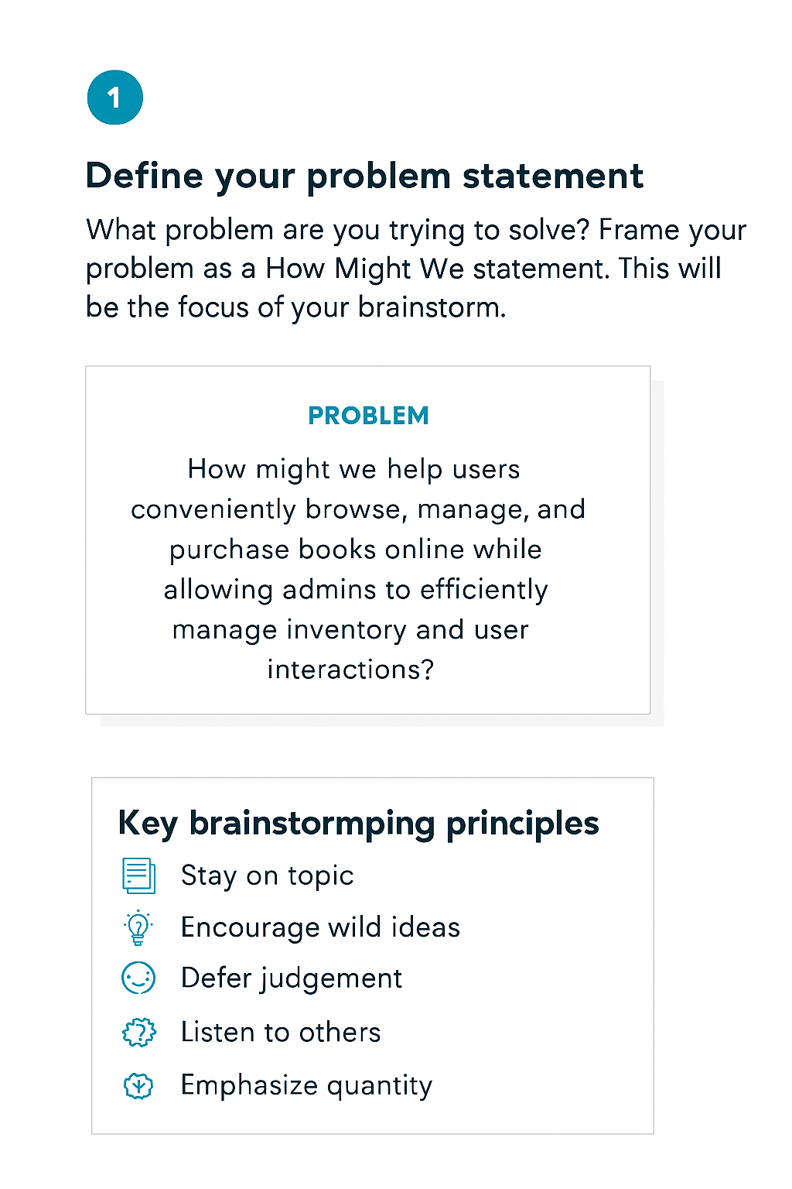

**Step-2: Brainstorm, Idea Listing and Grouping**

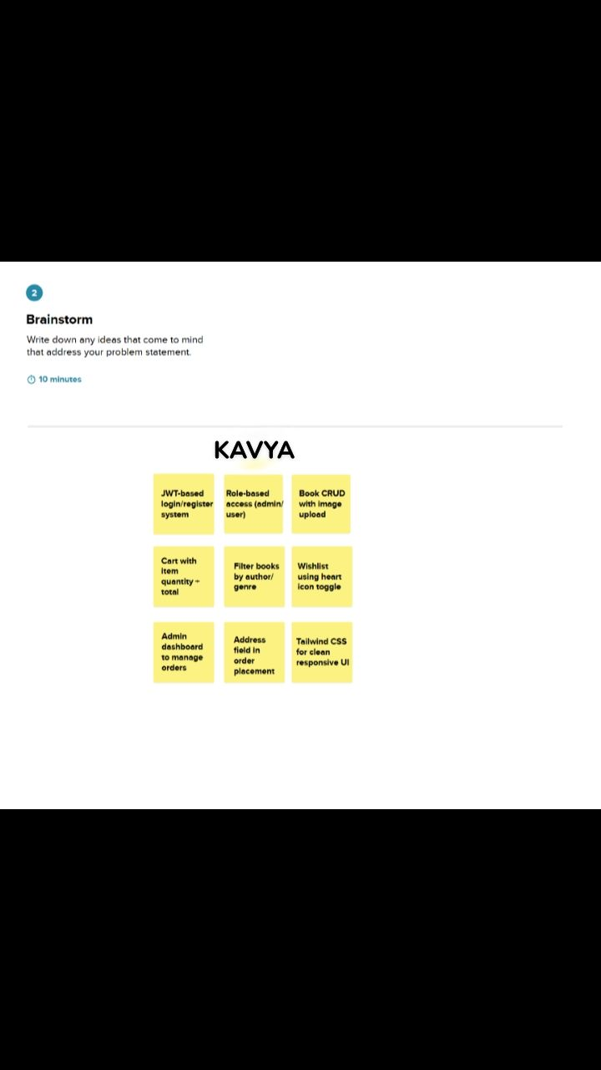

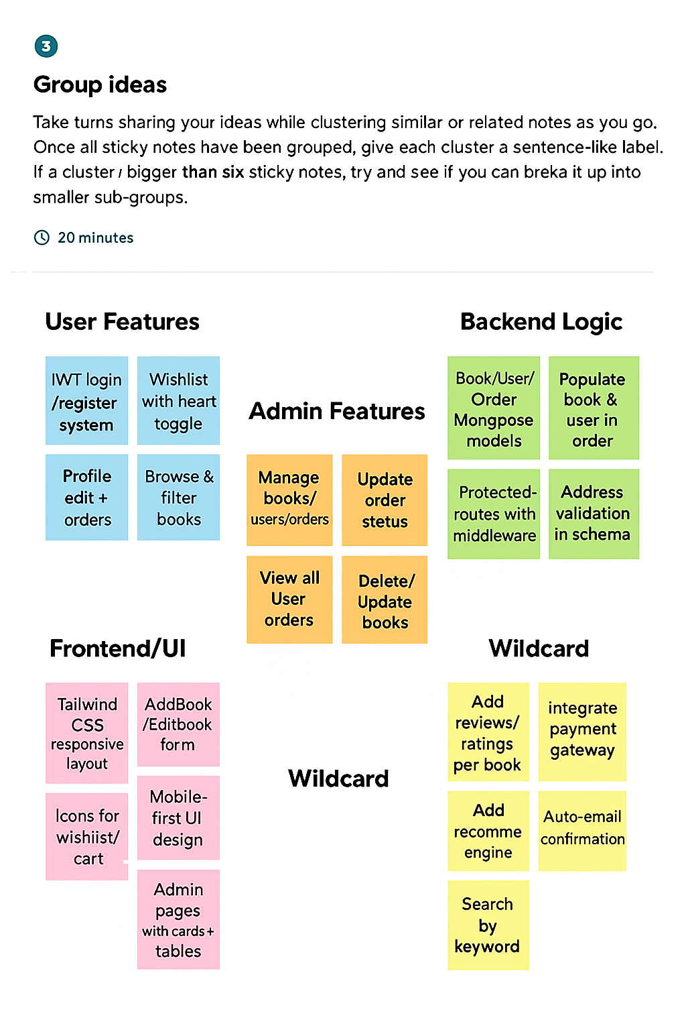

**Step-3: Idea Prioritization**

